
CENTRAL BOARD OF SECONDARY EDUCATION


JAWAHAR NAVODAYA VIDYALAYA
TARIKHET ALMORA UTTARAKHAND 263663

COMPUTER SCIENCE (083)
PROJECT FILE
On
SOCIAL MEDIA SURVEY SYSTEM
USING PYTHON’S TKINTER LIBRARY AND MySQL
SUBMITTED BY :

S. No | Name | CBSE Roll
CLASS : XII
SECTION : SCIENCE

PRINCIPAL
(D.S RAWAT)

INTERNAL EXAMINER
(PANKAJ BHILINGWAL)

EXTERNAL EXAMINER

ACKNOWLEDGEMENT

I wish to express my deep sense of gratitude and indebtedness to our learned teacher Pankaj Bhilingwal, PGT Computer Science, J.N.V Tarikhet Almora for his invaluable help, advice and guidance in the preparation of this project file.
I am also greatly indebted to our principal D.S Rawat and school authorities for providing me with the facilities and requisite laboratory conditions for making this project file.
I also extend my thanks to a number of teachers, my classmates and friends who helped me to complete this project file successfully.
NAME :

S. No | Name | CBSE Roll

CLASS : XII
SECTION : SCIENCE

CERTIFICATE

This is to certify that,
S. No | Name | CBSE Roll

Student of Class XII, J.N.V Tarikhet Almora has completed the PROJECT FILE during the academic year 2026-27 towards partial fulfilment of credit for the Computer Science Project evaluation of CBSE and submitted satisfactory report, as compiled in the following pages, under my supervision.

Internal Examiner External Examiner
Signature Signature

PREFACE

In the field of Computer Science, the term PROJECT refers to a Computerization Work that is completely performed by using a computer. Today when every field is going to be computerized means that all task of any field now a days done by using computer and their appropriate computer programs, then to do every field’s different-different works, today different programs or software’s are available in the form of Project.
Learning Python & MySQL in schools is a part of our syllabus, and according to the syllabus worked out by the CBSE, to which my school is affiliated, I enjoyed doing project work for the session 2026-27. I learned a lot, especially learning by doing was a great experience. The report is a summary of what I observed and learnt in school. My humble thanks are going to all the concerned related to my project.
I also feel that it is the right time to thank my teacher, who guided me during my project. I also feel that it is the right time to thank my parents, friends and my project partners for their constant assistance, cooperation extended by them time to time.

INDEX
Table of Contents
About Project 5
Social Media Survey System 5
Project Overview 5
Technology Stack 5
How to Run the Program 6
Flow Chart 7
Project Code 8
Output 20
Technological requirements: Hardware & Software 22
References 23

About Project

Social Media Survey System
The Social Media Survey System is a user-friendly application developed in Python, leveraging the Tkinter library for the graphical user interface (GUI) and MySQL as the database backend. This project serves as a survey tool to collect and manage information about users' social media preferences.

Project Overview

Objective:
The main objective of the Social Media Survey System is to gather insights into users' social media habits. By utilizing a Tkinter-based GUI, users can easily input their name, select the social media platforms they use, specify the platform they spend the most and least time on, and provide their date of birth. The collected data is then stored in a MySQL database for efficient retrieval and analysis.
Key Features:
- Data Collection: Users can input their name, select social media platforms used, and specify the most and least used platforms.
- Data Storage: Utilizes MySQL to store survey responses, ensuring organized and accessible data management.
- Data Retrieval: Offers functionalities to view survey information and user details, aiding in data analysis.
- Data Deletion: Provides a secure and user-friendly way to delete specific survey entries based on user ID.

Technology Stack

- Programming Language: Python
- GUI Library: Tkinter
- Database: MySQL
- Modules Used: tkinter, mysql.connector
Description:
The project relies on Tkinter for creating an interactive GUI, allowing users to input survey data seamlessly. The mysql.connector module facilitates the connection to a MySQL database, where user survey responses and personal details are stored in separate tables.

How to Run the Program

- Ensure Python is installed on your system.
- Install the mysql-connector module using pip install mysql-connector.
- Set up a MySQL server locally or remotely and update the connection details in the Python script.
- Execute the main program file to launch the GUI.
- Input survey data and explore functionalities such as viewing, deleting, and analysing collected information.

This Social Media Survey System streamlines the process of data collection and analysis, providing valuable insights into users' social media preferences.

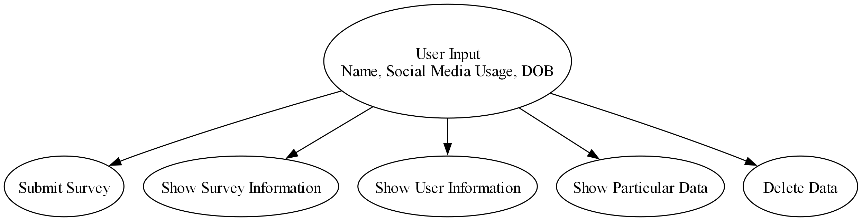
Flow Chart

Project Code
from tkinter import *
from tkinter import ttk
import mysql.connector

root = Tk()
root.configure(bg='#ffeae0')

# Connect to MySQL database
my_db = mysql.connector.connect(host='localhost', user='root', password='admin')
my_db_cursor = my_db.cursor()
my_db_cursor.execute('CREATE DATABASE IF NOT EXISTS survey')
my_db.commit()

my_db1 = mysql.connector.connect(host='localhost', user='root', password='admin', database='survey')
cur = my_db1.cursor()
cur.execute('''CREATE TABLE IF NOT EXISTS survey_info
(
id INT PRIMARY KEY,
facebook VARCHAR(20),
instagram VARCHAR(20),
telegram VARCHAR(20),
twitter VARCHAR(20),
youtube VARCHAR(20),
reddit VARCHAR(20),
snapchat VARCHAR(20),
whatsapp VARCHAR(20),
quora VARCHAR(20),
tiktok VARCHAR(20),
most_time_spent VARCHAR(20),
least_time_used VARCHAR(20)
);''')

cur.execute('''CREATE TABLE IF NOT EXISTS user_info
(
roll INT PRIMARY KEY,
name VARCHAR(255),
date_of_birth DATE
);''')

def submit():
my_db1 = mysql.connector.connect(host='localhost', user='root', password='admin', database='survey')
cur = my_db1.cursor()

# Get the values of the checkboxes
checkbox_values = ['Yes' if var.get() else 'No' for var in checkboxes]

# Create a tuple with checkbox values and other data
survey_values = (
roll_entry.get(),checkbox_values[0], checkbox_values[1], checkbox_values[2], checkbox_values[3],
checkbox_values[4], checkbox_values[5], checkbox_values[6], checkbox_values[7],
checkbox_values[8], checkbox_values[9], clicked1.get(), clicked2.get()
)

b1 = 'INSERT INTO survey_info(id,facebook,instagram,telegram,twitter,youtube,reddit,snapchat,whatsapp,quora,tiktok,most_time_spent,least_time_used) VALUES(%s,%s,%s,%s,%s,%s,%s,%s,%s,%s,%s,%s,%s)'
cur.execute(b1, survey_values)

b2 = 'INSERT INTO user_info(roll, name, date_of_birth) VALUES(%s, %s, %s)'
user_values = (roll_entry.get(), name_entry.get(), dob_entry.get())
cur.execute(b2, user_values)

name_entry.delete(0, END)
roll_entry.delete(0, END)
for var in checkboxes:
var.set('No') # Reset checkboxes to 'No'
clicked1.set('select')
clicked2.set('select')
dob_entry.delete(0, END)
dob_entry.insert(0, 'YYYY-MM-DD')
my_db1.commit()
Label(root, text='Data Recorded', bg='#ffeae0').grid(columnspan=2)

def show_survey():
A = Tk()
A.configure(bg='#ffeae0')
A.title("Survey Information")

tree = ttk.Treeview(A)
tree["columns"] = ("Id", "Facebook", "Instagram", "Telegram", "Twitter", "YouTube", "Reddit", "Snapchat",
"WhatsApp", "Quora", "TikTok", "Most Time Spent", "Least Time Used")

# Define column headings
tree.heading("Id", text="Id")
tree.heading("Facebook", text="Facebook")
tree.heading("Instagram", text="Instagram")
tree.heading("Telegram", text="Telegram")
tree.heading("Twitter", text="Twitter")
tree.heading("YouTube", text="YouTube")
tree.heading("Reddit", text="Reddit")
tree.heading("Snapchat", text="Snapchat")
tree.heading("WhatsApp", text="WhatsApp")
tree.heading("Quora", text="Quora")
tree.heading("TikTok", text="TikTok")
tree.heading("Most Time Spent", text="Most Time Spent")
tree.heading("Least Time Used", text="Least Time Used")

# Set column widths statically
tree.column("Id", width=50)
tree.column("Facebook", width=60)
tree.column("Instagram", width=70)
tree.column("Telegram", width=60)
tree.column("Twitter", width=60)
tree.column("YouTube", width=60)
tree.column("Reddit", width=60)
tree.column("Snapchat", width=70)
tree.column("WhatsApp", width=80)
tree.column("Quora", width=60)
tree.column("TikTok", width=60)
tree.column("Most Time Spent", width=120)
tree.column("Least Time Used", width=120)
tree["show"] = "headings" # Hide the default first column
# Populate treeview with data
cur.execute('SELECT * FROM survey_info')
for row in cur:
tree.insert("", "end", values=row)

# Add treeview to the window
tree.grid(row=1, column=0, padx=1, pady=1, columnspan=2, sticky="nsew")

# Add a vertical scrollbar
scrollbar = ttk.Scrollbar(A, orient="vertical", command=tree.yview)
scrollbar.grid(row=1, column=2, sticky="ns")
tree.configure(yscrollcommand=scrollbar.set)

A.mainloop()

def sort_treeview(tree, col, reverse):
items = [(tree.set(k, col), k) for k in tree.get_children('')]
items.sort(reverse=reverse)
# rearrange items in sorted positions
for index, (val, k) in enumerate(items):
tree.move(k, '', index)
tree.heading(col, command=lambda: sort_treeview(tree, col, not reverse))

def show_user_info():
B = Tk()
B.configure(bg='#ffeae0')
B.title("User Information")

tree = ttk.Treeview(B)
tree["columns"] = ("Id","Name", "Date of Birth")

# Define column headings with centered text
for col in tree["columns"]:
tree.heading(col, text=col, anchor="center")

# Set column widths
for col in tree["columns"]:
tree.column(col, width=100, anchor="center") # Adjust the width as needed
tree["show"] = "headings" # Hide the default first column

# Populate treeview with data
cur.execute('SELECT * FROM user_info')
for row in cur:
tree.insert("", "end", values=row)

# Add treeview to the window
tree.grid(row=1, column=0, padx=10, pady=10, columnspan=2, sticky="nsew")

# Add a vertical scrollbar
scrollbar = ttk.Scrollbar(B, orient="vertical", command=tree.yview)
scrollbar.grid(row=1, column=2, sticky="ns")
tree.configure(yscrollcommand=scrollbar.set)

B.mainloop()

def delete_data():
if vall.get() == '':
Label(C, text='Enter id', bg='#ffeae0').grid(columnspan=2)
else:
s = (int(vall.get()),)
b2 = 'SELECT * FROM user_info where roll=%s'
cur.execute(b2, s)
ch = ''
for a in cur:
ch = ch + str(a[0])
if ch == '':
Label(C, text=f'No data exists where id = {vall.get()}', bg='#ffeae0').grid(columnspan=2)
vall.delete(0, END)
elif ch != '':
s = (int(vall.get()),)
b = 'DELETE FROM survey_info where id=%s'
cur.execute(b, s)
b1 = 'DELETE FROM user_info where roll=%s'
cur.execute(b1, s)
Label(C, text='Data deleted', bg='#ffeae0').grid(columnspan=2)
vall.delete(0, END)
my_db1.commit()

def delete_data_window():
global vall
global C
C = Tk()
C.configure(bg='#ffeae0')
Label(C, text='DELETE WINDOW', bg='#ffeae0').grid(row=0, column=0, columnspan=2)
Label(C, text='Enter Id of data to be deleted', bg='#ffeae0').grid(row=1, column=0)
vall = Entry(C)
vall.grid(row=1, column=1)
Button(C, text='DELETE DATA', command=delete_data).grid(row=2, column=0, columnspan=2, pady=10, padx=10, ipadx=100)
C.mainloop()

def show_data():
if valll.get() == '':
Label(D, text='Enter id', bg='#ffeae0').grid(columnspan=2)
else:
s = (int(valll.get()),)
b2 = 'SELECT * FROM user_info where roll=%s'
cur.execute(b2, s)
ch = ''
for a in cur:
ch = ch + str(a[0])
if ch == '':
Label(D, text=f'No data exists where id = {valll.get()}', bg='#ffeae0').grid(columnspan=2)
valll.delete(0, END)
elif ch != '':
s = (int(valll.get()),)
b = 'SELECT * FROM survey_info where id=%s'
cur.execute(b, s)

# Fetch all rows from the result set
rows = cur.fetchall()

E = Tk()
E.configure(bg='#ffeae0')
E.title("Data Information")

tree = ttk.Treeview(E)
tree["columns"] = ("Survey ID", "Facebook", "Instagram", "Telegram", "Twitter", "YouTube", "Reddit",
"Snapchat", "WhatsApp", "Quora", "TikTok", "Most Time Spent", "Least Time Used")

# Configure column headings
for col in tree["columns"]:
tree.heading(col, text=col, anchor='center')
tree.column(col, anchor='center', width=60) # Adjust width as needed
tree["show"] = "headings" # Hide the default first column
# Populate treeview with data using the fetched rows
for row in rows:
tree.insert("", "end", values=row)

# Add a scrollbar to the treeview
scrollbar = ttk.Scrollbar(E, orient="vertical", command=tree.yview)
scrollbar.pack(side="right", fill="y")
tree.configure(yscrollcommand=scrollbar.set)

tree.pack(expand=YES, fill=BOTH)
valll.delete(0, END)
my_db1.commit()
E.mainloop()

def show_particular_data_window():
global D
global valll
D = Tk()
D.configure(bg='#ffeae0')
Label(D, text='VIEW WINDOW', bg='#ffeae0').grid(row=0, column=0, columnspan=2)
Label(D, text='Enter id of data to view', bg='#ffeae0').grid(row=1, column=0)
valll = Entry(D)
valll.grid(row=1, column=1)
Button(D, text='VIEW', command=show_data).grid(row=2, columnspan=2)
D.mainloop()

Label(root, text='Name', bg='#ffeae0').grid(row=0, column=0)
Label(root, text='Roll', bg='#ffeae0').grid(row=0, column=2)
Label(root, text='Select the social media sites you use:', bg='#ffeae0').grid(row=1, column=0)

checkboxes = []
options = [
'facebook', 'instagram', 'telegram', 'twitter', 'youtube', 'reddit', 'snapchat', 'whatsapp', 'quora', 'tiktok'
]

# Create Checkbuttons in a grid layout
row_num = 2
col_num = 0
for option in options:
var = BooleanVar()
checkbox = Checkbutton(root, text=option, variable=var, onvalue=True, offvalue=False, justify='left', bg='#ffeae0')
checkbox.deselect()
checkbox.grid(row=row_num, column=col_num, sticky=W, padx=5, pady=5)
checkboxes.append(var)

col_num += 1
if col_num == 5: # Adjust the number of columns as needed
col_num = 0
row_num += 1

name_entry = Entry(root)
name_entry.grid(row=0, column=1)
name_entry.insert(0, '')

roll_entry = Entry(root)
roll_entry.grid(row=0, column=3)
roll_entry.insert(0, '')

Label(root, text='which social media site you use most', bg='#ffeae0').grid(row=12, column=0)
Label(root, text='which social media site you use least', bg='#ffeae0').grid(row=13, column=0)

clicked1 = StringVar()
clicked1.set('select')
drop1 = OptionMenu(root, clicked1, *options)
drop1.grid(row=12, column=1)

clicked2 = StringVar()
clicked2.set('select')
drop2 = OptionMenu(root, clicked2, *options)
drop2.grid(row=13, column=1)

Label(root, text='Date of birth', bg='#ffeae0').grid(row=14, column=0)

dob_entry = Entry(root)
dob_entry.insert(0, 'YYYY-MM-DD')
dob_entry.grid(row=14, column=1)

Button(root, text='SUBMIT', command=submit).grid(row=15, column=0, columnspan=2, pady=10, padx=10, ipadx=100)
my_db1.commit()

Button(root, text='SHOW SURVEY INFO', command=show_survey).grid(row=16, column=0, columnspan=2, pady=10, padx=10, ipadx=100)

Button(root, text='SHOW USER INFO', command=show_user_info).grid(row=17, column=0, columnspan=2, pady=10, padx=10, ipadx=100)

Button(root, text='SHOW PARTICULAR DATA', command=show_particular_data_window).grid(row=18, column=0, columnspan=2, pady=10, padx=10, ipadx=100)

Button(root, text='DELETE DATA', command=delete_data_window).grid(row=19, column=0, columnspan=2, pady=10, padx=10, ipadx=100)

root.mainloop()

Output

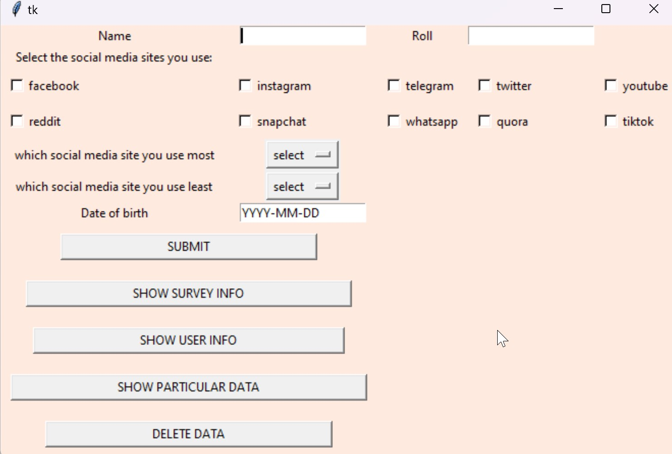

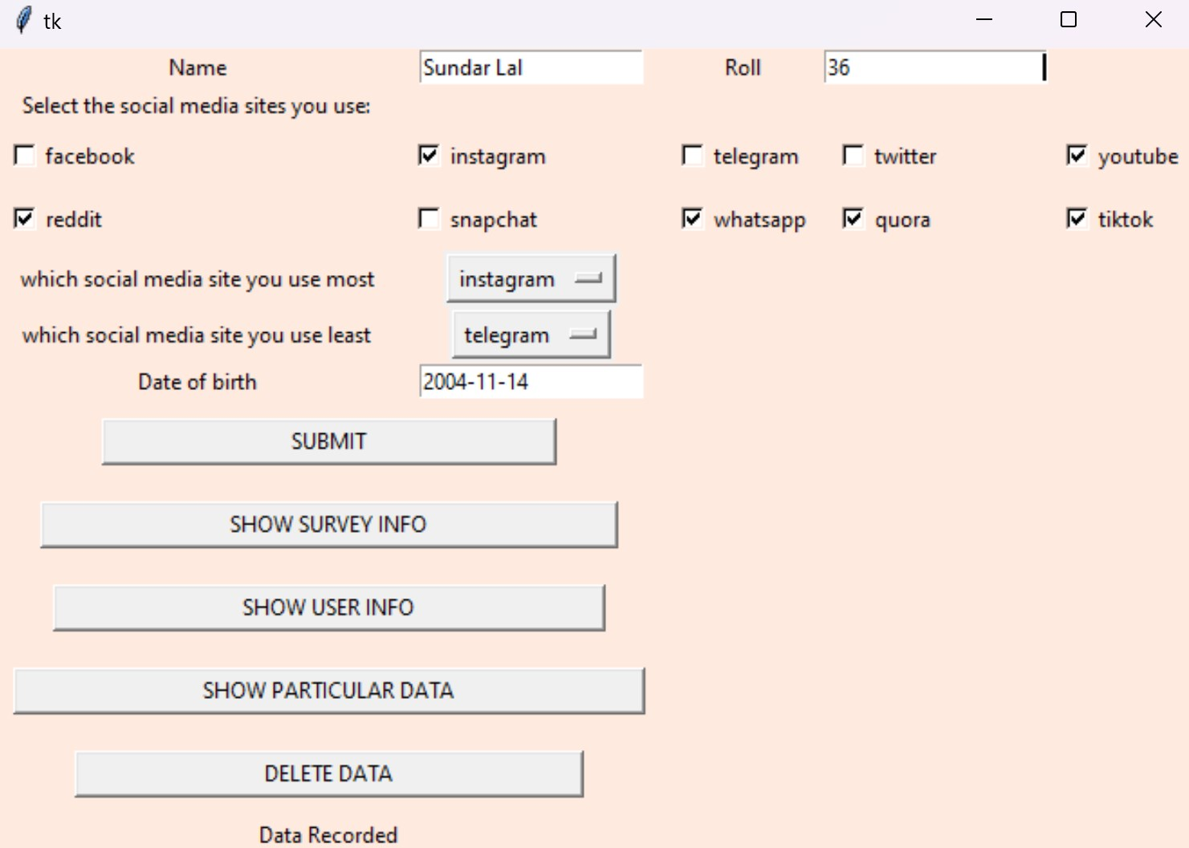
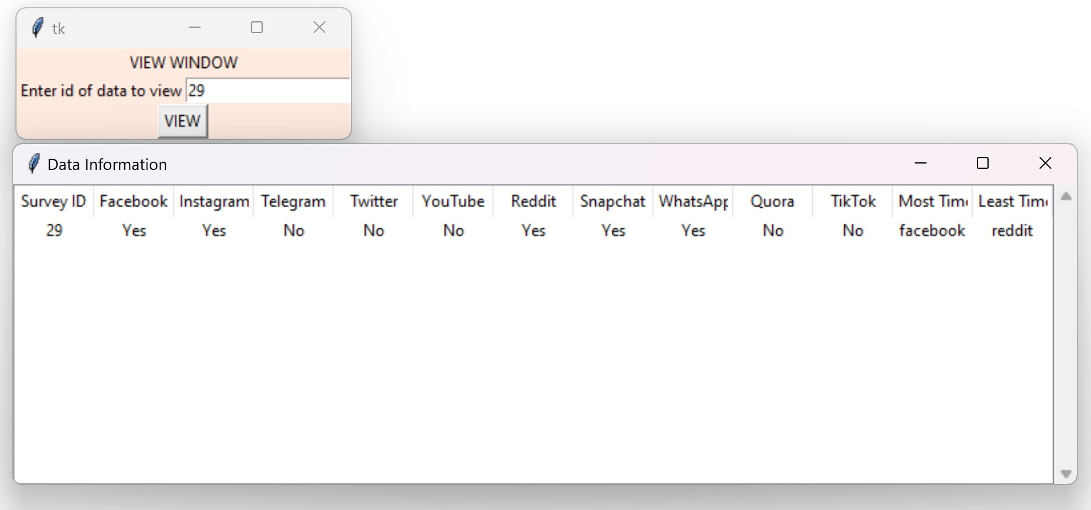
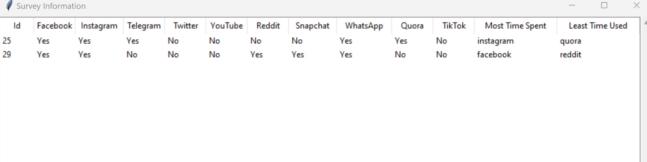
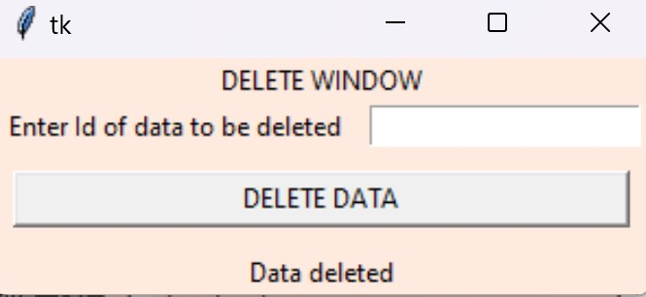
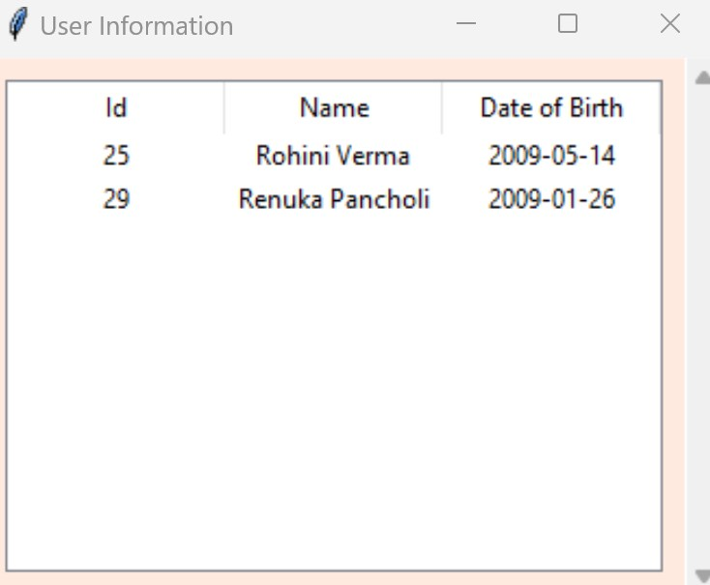

Technological requirements: Hardware & Software

Software
- Python
- VS Code
- MySQL

Hardware
- Laptop/PC

References

- https://www.python.org/
- https://realpython.com/python-gui-tkinter/
- https://www.tutorialspoint.com/python/python_gui_programming.htm
- https://codewithap.com/mysql-crud-operations-python/

